**University of Michigan – Dearborn**

**Department of Computer and Information Science**

**CIS 150L – Fall 2014**

Lab 12

Srinivas Simhan

12/01/14

**Table of Content**

1. Question 1 3
   1. Screenshot 3
   2. Source Code 3
2. Question 2 6
   1. Screenshot 6
   2. Source Code 6
3. Question 3 7
   1. Screenshot 7
   2. Source Code 7
4. **Question 1**
   1. **Screenshot**

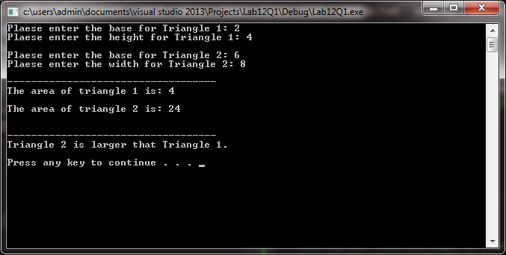

* 1. **Source Code**

**Header**

//Purpose: Header File for Triangle Class

//Author: Srinivas Simhan

//Date Created: 11/30/14

//Date Modified: 11/30/14

#ifndef TRIANGLE_H

#define TRIANGLE_H

class Triangle

{

private:

float base; //base of the triangle

float height; //height of the triangle

public:

//get and set functions

float getBase();

void setBase(float);

float getHeight();

void setHeight(float);

//functions to compute area

float computeArea();

};

#endif;

**Implementation**

//Purpose: Implementation File for Triangle Class

//Author: Srinivas Simhan

//Date Created: 11/30/14

//Date Modified: 11/30/14

#include "Triangle.h"

using namespace std;

//Purpose: Get Base

//Author: Srinivas Simhan

//Date Created: 11/30/14

//Date Modified: 11/30/14

float Triangle::getBase()

{

return base;

}

//Purpose: Set Base

//Author: Srinivas Simhan

//Date Created: 11/30/14

//Date Modified: 11/30/14

void Triangle::setBase(float v)

{

base = v;

}

//Purpose: Get Height

//Author: Srinivas Simhan

//Date Created: 11/30/14

//Date Modified: 11/30/14

float Triangle::getHeight()

{

return height;

}

//Purpose: Set Height

//Author: Srinivas Simhan

//Date Created: 11/30/14

//Date Modified: 11/30/14

void Triangle::setHeight(float v)

{

height = v;

}

//Purpose: Compute the Area

//Author: Srinivas Simhan

//Date Created: 11/30/14

//Date Modified: 11/30/14

float Triangle::computeArea()

{

float area;

area = ((base * height)/2);

return area;

}

**Main**

//Purpose: Main Source Code File for Triangle Class

//Author: Srinivas Simhan

//Date Created: 11/30/14

//Date Modified: 11/30/14

#include "Triangle.h"

#include <iostream>

using namespace std;

int main()

{

float b1, h1; //base and height of triangle 1

float b2, h2; //base and height of triangle 2

float a1, a2; //area of triangles 1 and 2

float largerArea; //Larger Area of both triangles 1 and 2

Triangle t1, t2;

//Triangle 1

cout << "Plaese enter the base for Triangle 1: ";

cin >> b1;

t1.setBase(b1);

cout << "Plaese enter the height for Triangle 1: ";

cin >> h1;

t1.setHeight(h1);

a1 = t1.computeArea();

cout << endl;

//Rectangle 2

cout << "Plaese enter the base for Triangle 2: ";

cin >> b2;

t2.setBase(b2);

cout << "Plaese enter the width for Triangle 2: ";

cin >> h2;

t2.setHeight(h2);

a2 = t2.computeArea();

cout << endl;

cout << "-----------------------------------" << endl;

cout << "The area of triangle 1 is: " << a1 << endl << endl;

cout << "The area of triangle 2 is: " << a2 << endl << endl;

cout << endl;

cout << "-----------------------------------" << endl;

//Which Triangle has the Larger Area

if (a1 > a2)

{

cout << "Triangle 1 is larger than Triangle 2." << endl;

}

else if (a2 > a1)

{

cout << "Triangle 2 is larger that Triangle 1." << endl << endl;

}

system("pause");

return 0;

}}

1. **Question 2**

**2.1 Screenshot**

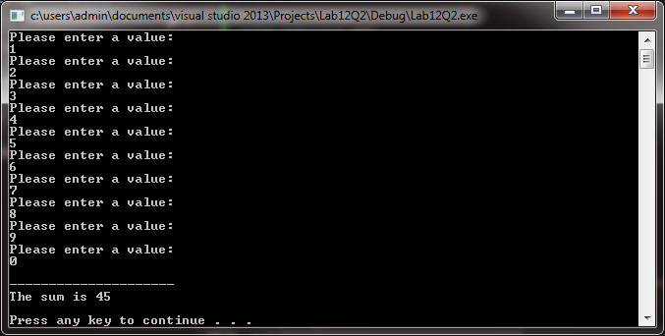

**2.2. Source Code**

// Purpose: Assign 10 Values into Array and Find Sum

// Author: Srinivas Simhan

// Date Created: 12/01/14

// Date Modified: 12/01/14

#include <iostream>

#include <string>

using namespace std;

int main()

{

int *x, *y;

int sum = 0;

x = new int[10];

y = new int;

for (int i = 0; i <= 9; i++)

{

cout << "Please enter a value: " << endl;

cin >> *x;

sum += *x;

(*y) = sum;

}

cout << endl << "---------------------" << endl << "The sum is " << (*y) << endl << endl ;

system("pause");

return 0;

}

1. **Question 3**

**3.1 Screenshot**

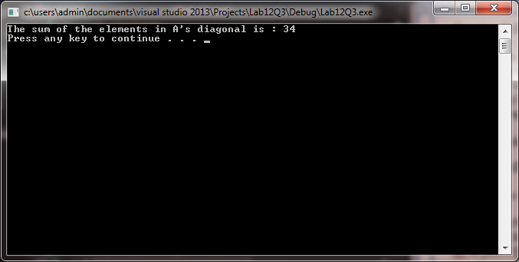

**3.2. Source Code**

// Purpose: Diagonal Sum of Matrix

// Author: Srinivas Simhan

// Date Created: 12/01/14

// Date Modified: 12/01/14

#include <iostream>

#include <cmath>

using namespace std;

const int ROW = 4;

const int COL = 4;

int A[ROW][COL] =

{

{ 1, 2, 3, 4 },

{ 5, 6, 7, 8 },

{ 9, 10, 11, 12 },

{ 13, 14, 15, 16 }

};

float diagonal;

int main()

{

for (int x = 0; x < 4; x++)

{

for (int y = 0; y < 4; y++)

{

if (x == y)

{

diagonal += A[x][y];

}

else

{

diagonal += 0;

}

}

}

cout << "The sum of the elements in A's diagonal is : " << diagonal << endl;

system("pause");

}